**6th Grade World History**

**LS TEST 1 Study Guide**

1. What is longitude?
2. What is latitude?
3. What is a primary source?
4. What is a secondary source?
5. What is the difference between both sources?
6. How are these sources used to teach us about ancient civilizations?
7. List three examples of a primary source.
8. List three examples of a secondary source.
9. 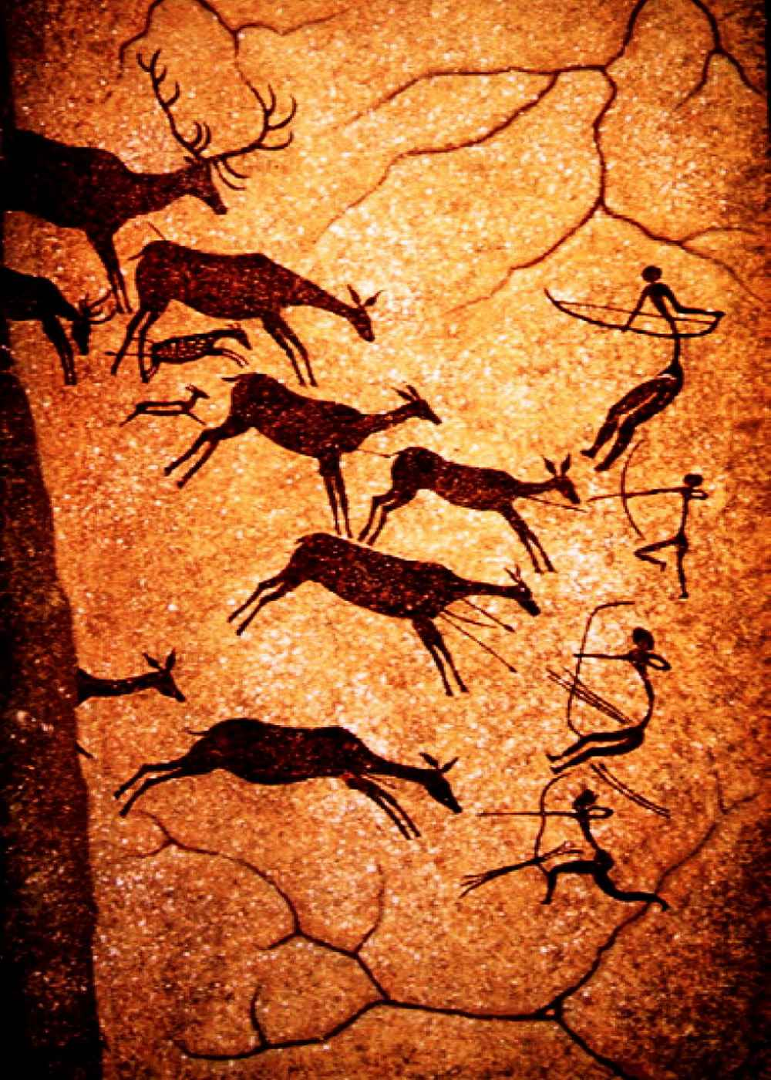
   1. Is this a primary or secondary source? What does this image tell us about this time period?
10. What is prehistory?
11. What is the job of an archaeologist?
12. Define equator and prime meridian.
13. 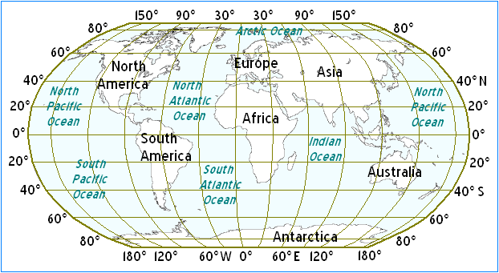
    1. Locate the prime meridian and equator.
    2. What continents does the equator run through?
    3. What continents does the prime meridian run through?
14. 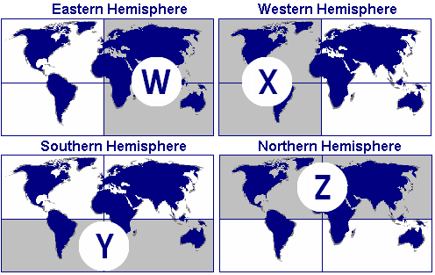
    1. What two hemispheres does the point 40 degrees south latitude and 10 degrees west longitude run through?
15. 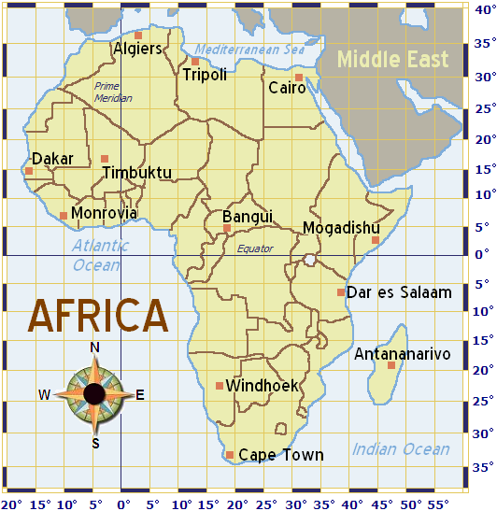
    1. Looking at the map above, which city is nearest 30 degrees North latitude and 30 degrees East longitude?
16. 
    1. A ship is at 20 degrees South latitude and 20 degrees West longitude. What ocean is the ship located in?